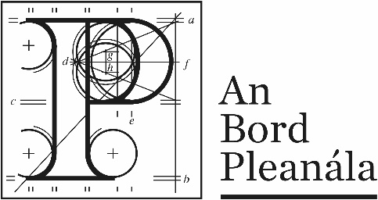 | Memorandum
 | ABP-311528-21
To: | Board Member
From: | A. Doherty, Executive Officer
Re: | Construction of a 2 storey 220kV GIS substation known as 'Mooretown', 4 no. underground transmission cables and all associated and ancillary site development and construction works. Lands adjacent to Huntstown Power Station, North Road, Finglas, Dublin 11.
Date: | 17th August 2023

In accordance with the provisions of section 182B of the Planning and Development Act 2000, as amended, a breakdown of the Board’s costs is set out in the attached Appendix to the draft Board Order as follows:
Board Costs
(1) | Cost (calculated based on Inspector’s time)  Inspector 1 (pre-application consultation) €3,062.5  Inspector 2 (application) €24,500 | €27,562
(2) | Costs invoiced to Board | N/A
 | Total chargeable costs | €27562
Board Fees
(3) | Application Fee - €100,000  Pre-application Consultation Fee- €4,500 | €104,500
(4) | Observer fees paid | N/A
 | Total | €104,500
 | Net amount to be refunded to applicant | €76,938

Therefore, the amount to be refunded to the applicant is €76,938 as per Appendix 1 – attached to draft Board Order.
File for Direction please in relation to Costs.

